without adv

normal = hate

1 run

training 1 epoch...

598.789163351059 seconds used......

1 training finished! average train loss: 0.3887447084018813

evaluating...

Confusion matrix, without normalization

[[ 283 480 229]

[ 65 5202 142]

[ 160 647 9985]]

Normalized confusion matrix

[[0.28528226 0.48387097 0.23084677]

[0.01201701 0.96173045 0.02625254]

[0.0148258 0.05995182 0.92522239]]

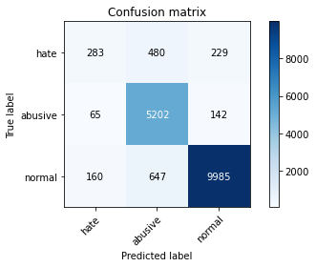

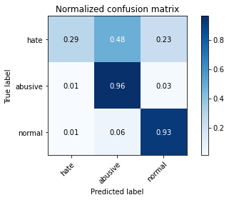

precision recall f1-score support

hate 0.56 0.29 0.38 992

abusive 0.82 0.96 0.89 5409

normal 0.96 0.93 0.94 10792

accuracy 0.90 17193

macro avg 0.78 0.72 0.74 17193

weighted avg 0.90 0.90 0.89 17193

average eval_loss: 0.3743816634510146, accuracy: 0.8997847961379631

training 2 epoch...

598.4771893024445 seconds used......

2 training finished! average train loss: 0.3018122845691153

evaluating...

Confusion matrix, without normalization

[[ 519 372 101]

[ 246 5108 55]

[1321 966 8505]]

Normalized confusion matrix

[[0.52318548 0.375 0.10181452]

[0.04547976 0.94435201 0.01016824]

[0.12240549 0.08951075 0.78808377]]

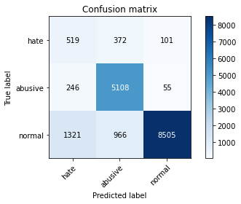

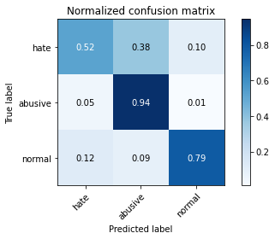

precision recall f1-score support

hate 0.25 0.52 0.34 992

abusive 0.79 0.94 0.86 5409

normal 0.98 0.79 0.87 10792

accuracy 0.82 17193

macro avg 0.67 0.75 0.69 17193

weighted avg 0.88 0.82 0.84 17193

average eval_loss: 0.5509121094592089, accuracy: 0.8219624265689525

training 3 epoch...

598.7947163581848 seconds used......

3 training finished! average train loss: 0.22954989504404097

evaluating...

Confusion matrix, without normalization

[[ 532 338 122]

[ 294 5047 68]

[1338 759 8695]]

Normalized confusion matrix

[[0.53629032 0.34072581 0.12298387]

[0.05435385 0.93307451 0.01257164]

[0.12398073 0.07032987 0.8056894 ]]

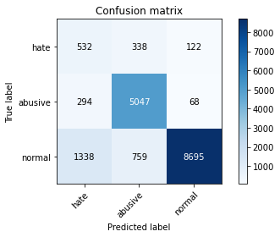

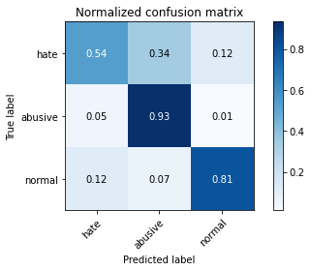

precision recall f1-score support

hate 0.25 0.54 0.34 992

abusive 0.82 0.93 0.87 5409

normal 0.98 0.81 0.88 10792

accuracy 0.83 17193

macro avg 0.68 0.76 0.70 17193

weighted avg 0.89 0.83 0.85 17193

average eval_loss: 0.5580236104425302, accuracy: 0.8302216018146921

training 4 epoch...

598.9315252304077 seconds used......

4 training finished! average train loss: 0.15831453260620587

evaluating...

Confusion matrix, without normalization

[[ 527 352 113]

[ 285 5060 64]

[1638 756 8398]]

Normalized confusion matrix

[[0.53125 0.35483871 0.11391129]

[0.05268996 0.93547791 0.01183213]

[0.1517791 0.07005189 0.77816901]]

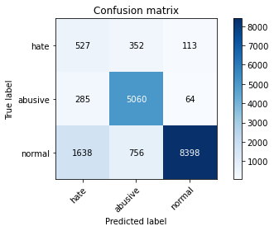

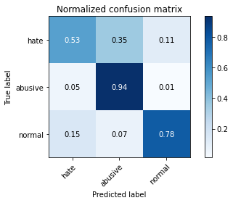

precision recall f1-score support

hate 0.22 0.53 0.31 992

abusive 0.82 0.94 0.87 5409

normal 0.98 0.78 0.87 10792

accuracy 0.81 17193

macro avg 0.67 0.75 0.68 17193

weighted avg 0.89 0.81 0.84 17193

average eval_loss: 0.6425914591091664, accuracy: 0.8134124352934333

training 5 epoch...

598.8501808643341 seconds used......

5 training finished! average train loss: 0.10930954450100708

evaluating...

Confusion matrix, without normalization

[[ 530 346 116]

[ 352 4991 66]

[1665 853 8274]]

Normalized confusion matrix

[[0.53427419 0.34879032 0.11693548]

[0.06507672 0.92272139 0.01220189]

[0.15428095 0.07904003 0.76667902]]

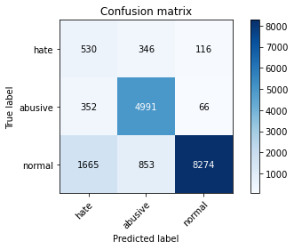

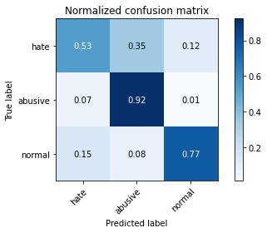

precision recall f1-score support

hate 0.21 0.53 0.30 992

abusive 0.81 0.92 0.86 5409

normal 0.98 0.77 0.86 10792

accuracy 0.80 17193

macro avg 0.66 0.74 0.67 17193

weighted avg 0.88 0.80 0.83 17193

average eval_loss: 0.8268706901193879, accuracy: 0.80236142616181

2 run

training 1 epoch...

596.518367767334 seconds used......

1 training finished! average train loss: 0.38657112559973655

evaluating...

Confusion matrix, without normalization

[[ 371 457 164]

[ 100 5218 91]

[ 465 843 9484]]

Normalized confusion matrix

[[0.37399194 0.46068548 0.16532258]

[0.01848771 0.96468848 0.01682381]

[0.04308747 0.07811342 0.87879911]]

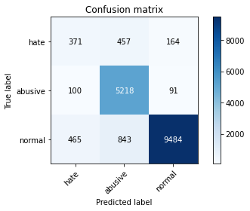

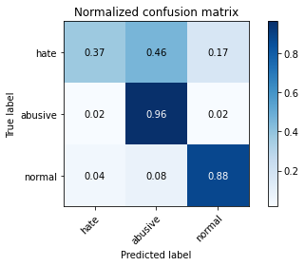

precision recall f1-score support

hate 0.40 0.37 0.38 992

abusive 0.80 0.96 0.87 5409

normal 0.97 0.88 0.92 10792

accuracy 0.88 17193

macro avg 0.72 0.74 0.73 17193

weighted avg 0.89 0.88 0.88 17193

average eval_loss: 0.4259464860568906, accuracy: 0.8766940033734659

training 2 epoch...

596.2679550647736 seconds used......

2 training finished! average train loss: 0.29942023993148165

evaluating...

Confusion matrix, without normalization

[[ 501 397 94]

[ 211 5140 58]

[1673 777 8342]]

Normalized confusion matrix

[[0.50504032 0.40020161 0.09475806]

[0.03900906 0.95026807 0.01072287]

[0.15502224 0.07199778 0.77297999]]

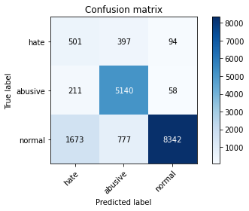

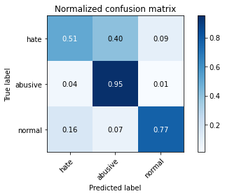

precision recall f1-score support

hate 0.21 0.51 0.30 992

abusive 0.81 0.95 0.88 5409

normal 0.98 0.77 0.87 10792

accuracy 0.81 17193

macro avg 0.67 0.74 0.68 17193

weighted avg 0.88 0.81 0.84 17193

average eval_loss: 0.558464853370259, accuracy: 0.8132961088815216

training 3 epoch...

596.079553604126 seconds used......

3 training finished! average train loss: 0.23035582543431157

evaluating...

Confusion matrix, without normalization

[[ 425 422 145]

[ 151 5183 75]

[ 806 1027 8959]]

Normalized confusion matrix

[[0.42842742 0.42540323 0.14616935]

[0.02791644 0.95821779 0.01386578]

[0.07468495 0.09516308 0.83015196]]

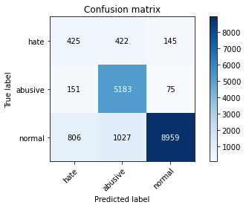

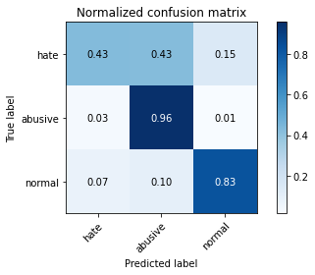

precision recall f1-score support

hate 0.31 0.43 0.36 992

abusive 0.78 0.96 0.86 5409

normal 0.98 0.83 0.90 10792

accuracy 0.85 17193

macro avg 0.69 0.74 0.71 17193

weighted avg 0.88 0.85 0.85 17193

average eval_loss: 0.5195830840292538, accuracy: 0.8472634211597744

training 4 epoch...

596.0110402107239 seconds used......

4 training finished! average train loss: 0.16369746906914004

evaluating...

Confusion matrix, without normalization

[[ 424 452 116]

[ 181 5170 58]

[1248 1320 8224]]

Normalized confusion matrix

[[0.42741935 0.45564516 0.11693548]

[0.03346275 0.95581438 0.01072287]

[0.11564122 0.12231282 0.76204596]]

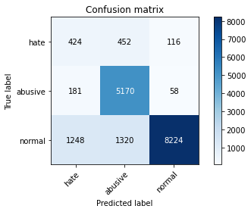

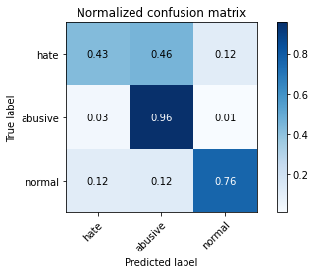

precision recall f1-score support

hate 0.23 0.43 0.30 992

abusive 0.74 0.96 0.84 5409

normal 0.98 0.76 0.86 10792

accuracy 0.80 17193

macro avg 0.65 0.72 0.66 17193

weighted avg 0.86 0.80 0.82 17193

average eval_loss: 0.7704621169239629, accuracy: 0.803699179898796

training 5 epoch...

596.0013613700867 seconds used......

5 training finished! average train loss: 0.11281380280659688

evaluating...

Confusion matrix, without normalization

[[ 580 310 102]

[ 435 4927 47]

[1836 1157 7799]]

Normalized confusion matrix

[[0.58467742 0.3125 0.10282258]

[0.08042152 0.91088926 0.00868922]

[0.17012602 0.10720904 0.72266494]]

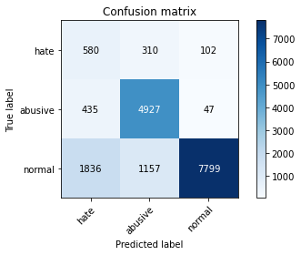

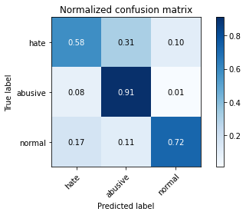

precision recall f1-score support

hate 0.20 0.58 0.30 992

abusive 0.77 0.91 0.83 5409

normal 0.98 0.72 0.83 10792

accuracy 0.77 17193

macro avg 0.65 0.74 0.66 17193

weighted avg 0.87 0.77 0.80 17193

average eval_loss: 1.0275112303320406, accuracy: 0.773919618449369